December 2025

As the year winds down, we want to make sure you’re getting the most out of your TGNA benefits. Check your coverage details and take advantage of any benefits you still have before December ends!

For 24/7 Virtual Care During the Holidays, Start with the Heart
Whether you’re relaxing at home, or traveling for the holidays, your TGNA benefits make it easy to access virtual health services through Transcarent. Get the care you need, anytime, anywhere, for non-emergency concerns like pink eye, cold and flu, sore throat, allergies, and more!  With virtual visits, you and your covered family members can visit with providers 24/7 from the comfort of your home – or wherever you are! You can video chat with licensed doctors by  web, phone or mobile app. Doctors can even issue prescriptions when necessary. |  |   Access virtual health services through member.transcarent.com or download the Transcarent mobile app. You can also call 888-994-8481.
Use Your Flexible Spending Accounts (FSA) Dollars Before Year End
December 31, 2025, is the deadline for submitting eligible expenses for Flexible Spending Accounts (FSAs). These accounts have a “use it or lose it” rule and you’ll forfeit any remaining balance you have after December 31.

- Health Care FSA – Funds can be used to pay for medical, dental, vision, and hearing expenses not covered by your health plan, such as deductibles, coinsurance, copays or over-the-counter medications.  - Limited Purpose FSA – Can be used to pay for dental and vision expenses. You can use the account for medical expenses after you’ve met your annual medical plan deductible.  - Dependent Care FSA – Use your account to pay for expenses such as day care and after school programs for children under age 13, or elder care expenses that allow you to work or attend school full time. | 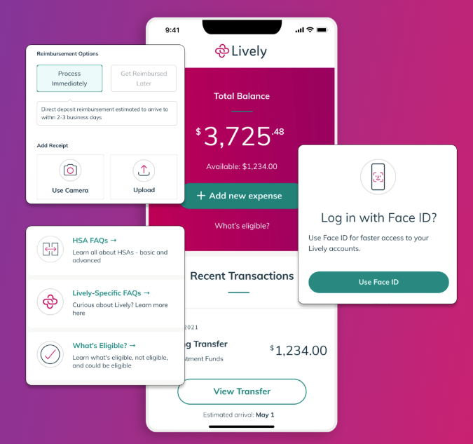
If you’ve already used your Health Care or Limited Purpose FSA to cover medical, dental and/or vision expenses, remember you can also use it for other eligible items like first-aid kits, cold packs and heating pads, contact lens solution and cleaning supplies, orthotic shoe inserts, and even crutches, canes and walkers. Visit the FSA store for more spending ideas.

If you have questions about covered expenses or if you have funds you haven’t claimed, be sure to visit livelyme.com or call 888-576-4837. You can also download the Lively mobile app to submit claims quickly and easily!

Want More Details About Your TG Benefits?
Be sure to visit our benefits website, tggroupbenefits.com (password: TGNA; location: United States).
There, you’ll find helpful information about all your benefits.

